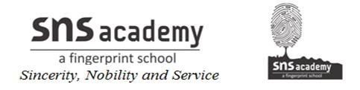
8. GOING PLACES
I. KEYWORDS.
1. Library
2. Market
3. Bank
4. Doctor
5. Mason
6. Door bell
7. Museum
8. Entertainment
9. Fire fighter
10. Nurse
11. Park
12. Police station
13. Porter
14. Railway station
15. Theatre
II. MATCH THE FOLLOWING.
1. Railway station – lots of shops – 4
2. Library – letters – 6
3. Hospital – books – 2
4. Shopping mall – service person – 8
5. Market – construct buildings – 7
6. Mail carrier – doctor and nurse – 3
7. Mason – Porter – 1
8. Gas agency – vegetables and fruits – 5

III. ANSWER THE FOLLOWING.
1. What is a neighbourhood?
A particular area where many families live is called a neighbourhood.
2. Give examples of public places.
School, hospital, bus stop, park, bank, post office, police station, library, market.
3. Give examples of recreational places.
Theatre, museum, park, amusement park, mall.
4. Write any 3 rules to follow in public places.
Do not talk loudly.
Do not talk to strangers.
Do not run around.

